|  |  |  |  |  |  |  |  |  |  |  |  |  |  |  |  |  |  |  |  |  |  |  |
| --- | --- | --- | --- | --- | --- | --- | --- | --- | --- | --- | --- | --- | --- | --- | --- | --- | --- | --- | --- | --- | --- | --- |
| **ini Project - 1**     |  |  | | --- | --- | | **Student Name/ID Number:** | **Wildan Luqmanul Hakim** | | **Unit Number and Title:** | ACWD Module 4 – Database Design & Implementation | | **Academic Year:** | **2022** | | **Unit Assessor:** | **Arvinder Kaur** | | **Project Title:** | Database Design for Community Portal | | **Issue Date:** | **23 July 2022** | | **Submission Date:** | **26 July 2022** | | **Internal Verifier Name:** |  | | **Date:** | **26 July 2022** |              |  | | --- | | **Learner declaration** | |  | | I certify that the work submitted for this assignment is my own and research sources are fully acknowledged.      Student signature: Date: 26 July 2022 | | |
| |  | | --- | | **Purpose of this project** | | **Purpose of this project**  To demonstrate your capabilities in the following areas:  • Design a Database for Community Portal | | **Submission Format** | | 1. Description of Entities in the database 2. Screen capture of the ER Diagram 3. Screen capture of Data 4. Screen capture of Normalized Database Design 5. Documentation of Relationships | | **Project Brief & Guidance** | | **Scenario:**    **Refer to the Project Scenario for the Module Project**  You have been approached by ‘ABC Jobs Pte Ltd’ as a website developer to develop a community portal for Software Developers. The project will be carried over through Module 3, Module 4, Module 5 and Capstone project. For this module the scope is to Design, Develop, Implement & Document Apache Struts Framework Website.  The Scope of the Project is to design a Community Portal Similar to Linkedin.com. Users will be able to register in the portal using the Registration Page. Users of the portal can search for other users using various parameters such as First Name, Last Name, Company Name, City & Country. Users will be able to view the Public Profile of users after searching them. The portal allow users to login, request for forgotten password and Update their profile information    The scope of the mini project is to design the database.    **The overview of the project is as below**  There are 2 types of users in this Community portal. They are   1. Software Programmer 2. Administrator     **Software Programmer should be able to perform following functions in the portal** | |

|  |  |
| --- | --- |
| |  | | --- | | 1. Allow the programmers to register in the portal, show a thank you page & send a registration confirmation email. 2. Search & Find Other Programmers after login and view their profile. 3. Provide Login Page 4. Provide password retrieval functionality. 5. Update their Profile after logging in.     Following Functionality is part of Database Design & Will be enhanced as features as required in the Capstone Project, Depending on time availability.     1. Send Messages to Each Other on the Portal 2. Create Threads & Post Replies to a Thread 3. Post Job Opportunities in the Portal     **Administrator should be able to perform following functions in the portal**   1. Administer user data. 2. Send bulk email inviting programmers to register on the community portal     **The portal consist of the following Key pages (For Reference)**   1. Community Portal Home Page 2. Registration Page 3. Registration Confirmation Page 4. Update Profile Page 5. Search Users Page 6. List Search Results 7. Public Profile Page 8. Registration Confirmation Email 9. Login Page 10. Forget Password Page 11. Design the Forget Password Confirmation Page     Following Functionality is part of Database Design and will not be part of development & Will be enhanced as features are required in the Capstone Project, Depending on time availability.   1. Send Messages 2. Read Messages 3. Post in Message Board 4. List Message Board 5. Read A Thread 6. Post Job Opportunities 7. List Job Opportunities & Responses     **The scope of this assignment**  The scope is to design the community portal database.   1. Identify the Entities in the Community Portal Database 2. Create ER Diagram for the Community Portal Database | |
| |  | | --- | | 1. **Create Sample data for all tables in the community portal (At least 3 tables)** 2. **Normalize the complete database to 3rd normal form (Provide screen capture of the normalization done)** 3. **Identify the relationships in tables & document them** | |

1. **Identify the Entities in the Community Portal Database**

|  |  |  |
| --- | --- | --- |
| **Name** | **Desc** | **Col** |
| User | Data users who have registered at ABC Jobs | user_id  first_name  last_name  company  city  country  email  password |
| User Profile | Data for user profiles at ABC Jobs | user_id  status_id  username  job_status  experience  company  bio |
| Admin | Admin data that manages the Abc Jobs website | admin_id  first_name  last_name  email  password |
| Job | Job vacancy data on ABC Jobs | job_id  company_name  job_desc  job_type |
| Company | Companies listed on abc jobs | company_id  company_name  company_address |
| Thread | Data of users who have created threads on ABC Jobs | thread_id  date  time  thread_desc  comment |
| Messages | Data message user to send messages between users | message_id  date  time  message  to  from |

1. **Create ER Diagram for the Community Portal Database**

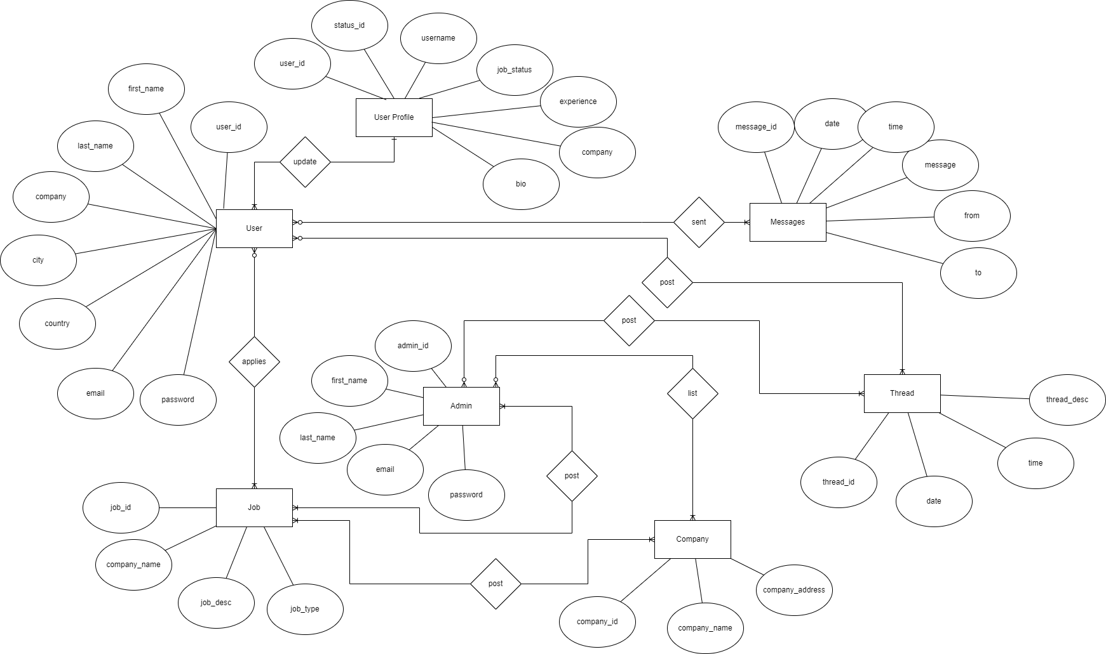

1. **Create Sample data for all tables in the community portal (At least 3 tables)**
2. **User**

|  |  |  |  |  |  |  |  |
| --- | --- | --- | --- | --- | --- | --- | --- |
| **user_id** | **first_name** | **last_name** | **company** | **city** | **country** | **email** | **password** |
| user1 | Wildan | Luqmanul Hakim | Google | Sumedang | Indonesia | [wildanluqmanul@gmail.com](mailto:wildanluqmanul@gmail.com) | password12345 |
| user2 | Peter | Parker | Amazon | London | United Kingdom | [peterparker@email.com](mailto:peterparker@email.com) | peter12345 |
| user3 | Harry | Potter | Intel | New York | USA | [hary3232@email.com](mailto:hary3232@email.com) | harry12345 |

1. **Job**

|  |  |  |  |
| --- | --- | --- | --- |
| **job_id** | **company_name** | **job_desc** | **job_type** |
| job1 | Google | We are looking for Full Stack Developer | Full-Time |
| job2 | Amazon | We are looking for Front-End Developer | Part-Time |
| job3 | Nvidia | We are looking for UI/UX Developer | Part-Time |

1. **Thread**

|  |  |  |  |
| --- | --- | --- | --- |
| **thread_id** | **time** | **date** | **thread_desc** |
| thread1 | 10:34 PM | 9/2/2021 | Very Happy |
| thread2 | 9:52 AM | 11/11/2021 | It's time to coffe |
| thread3 | 7:32 AM | 1/23/2022 | I'm working on Google |
| thread4 | 3:00 PM | 3/1/2022 | The best experience |
| thread5 | 7:00 AM | 4/13/2022 | I'm working on Amazon |
| thread6 | 8:03 AM | 4/19/2022 | I like this Nvidia Company |
| thread7 | 6:12 AM | 5/1/2022 | The best experience |

1. **Normalize the complete database to 3rd normal form (Provide screen capture of the normalization done)**

**UNF**

|  |  |  |  |  |  |  |
| --- | --- | --- | --- | --- | --- | --- |
| **user_id** | **first_name** | **last_name** | **job_id** | **company_name** | **thread_id** | **thread_desc** |
| user1 | Wildan | Luqmanul Hakim | job1  job2 | Google  Amazon | thread3  thread1 | I'm working on Google  Very Happy |
| user2 | Peter | Parker | job3 | Nvidia | thread6  thread7 | I like this Nvidia Company  The best experience |
| user3 | Harry | Potter | job2  job3 | Amazon  Nvidia | thread2  thread5 | It’s time to coffe  I'm working on Amazon |

**What is NF1**

A relation that satisfies NF1 is a relation in which each row and column intersection contains one and only one value. In order to have a single value, the UNF table is modified by separating the non-single cell values ​​into a new row so that the relationship is obtained as below

|  |  |  |  |  |  |  |
| --- | --- | --- | --- | --- | --- | --- |
| **user_id** | **first_name** | **last_name** | **job_id** | **company_name** | **thread_id** | **thread_desc** |
| user1 | Wildan | Luqmanul Hakim | job1 | Google | thread3 | I'm working on Google |
| user1 | Wildan | Luqmanul Hakim | job2 | Amazon | thread1 | Very Happy |
| user2 | Peter | Parker | job3 | Nvidia | thread6 | I like this Nvidia Company |
| user2 | Peter | Parker | job3 | Nvidia | thread7 | The best experience |
| user3 | Harry | Potter | job2 | Amazon | thread2 | It's time to coffe |
| user3 | Harry | Potter | job3 | Nvidia | thread5 | I'm working on Amazon |

**What is NF2**

A NF2 relation is a relay that satisfies NF1 and every non-primary key attribute has a fully functional dependency on the primary key. So, there are two things related to NF2 relations, namely primary keys and functional dependencies. can be modified as below

|  |  |  |
| --- | --- | --- |
| **user_id** | **job_id** | **thread_id** |
| user1 | job1 | thread3 |
| user1 | job2 | thread1 |
| user2 | job3 | thread6 |
| user2 | job3 | thread7 |
| user3 | job2 | thread2 |
| user3 | job3 | thread5 |

**What is NF3**

A NF3 relation is a relation that satisfies NF1, NF2 and attributes that are not primary keys do not have a transitive dependency on the primary key. The non-primary key attribute of every NF2 relation must be checked whether it has a transitive dependency.

**User**

|  |  |
| --- | --- |
| **user_id** | **job_id** |
| user1 | job1 |
| user1 | job2 |
| user2 | job3 |
| user2 | job3 |
| user3 | job2 |
| user3 | job3 |

**Jobs**

|  |  |  |
| --- | --- | --- |
| **job_id** | **company_name** | **thread_id** |
| job1 | Google | thread3 |
| job2 | Amazon | thread1 |
| job3 | Nvidia | thread6 |
| job3 | Nvidia | thread7 |
| job2 | Amazon | thread2 |
| job3 | Nvidia | thread5 |

**Thread**

|  |  |
| --- | --- |
| **thread_id** | **thread_desc** |
| thread3 | I'm working on Google |
| thread1 | Very Happy |
| thread6 | I like this Nvidia Company |
| thread7 | The best experience |
| thread2 | It's time to coffe |
| thread5 | I'm working on Amazon |

1. **Identify the relationships in tables & document them**

